
ADVERSE WEATHER
SITUATION REPORT
As at 6:30 pm on 18th May, 2025
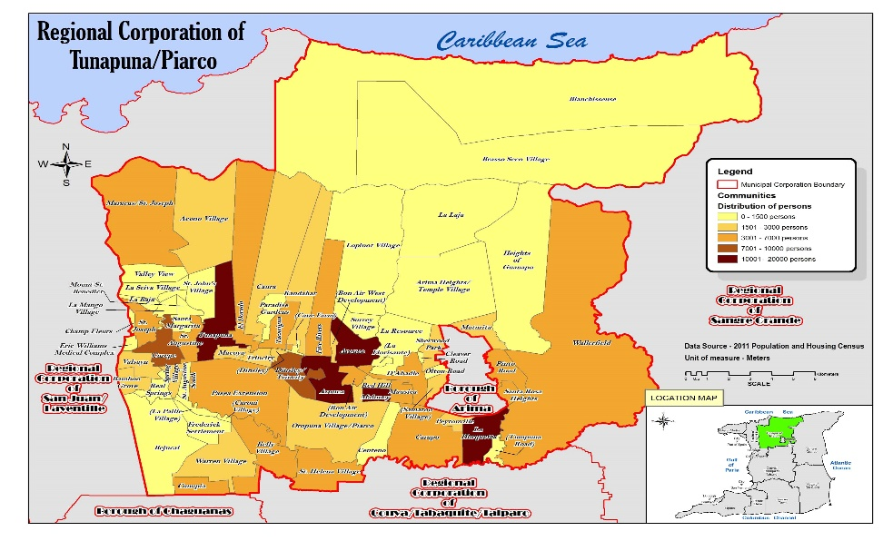
Location:
Tunapuna/Piarco Regional Corporation.

Present Activity:
Overcast

Alert Level:
Localized Flooding Alert #1 – Yellow Level on Saturday 17th May, 2025 6pm – Sun May 18th, 2025
Flooding Alert #2- Yellow Level – extended until Mon 19th May, 2025 6pm

Situation Overview:
On May 16th, 2025, the Trinidad and Tobago Meteorological Service (MET Office) issued a Localized Flood Alert - Yellow Level at 03:29pm.The start date is listed as Sat 17th May 6pm and end date as Sun 18th May, 2025 6pm.Since then, two more Yellow Alerts have been issued and remains in effect until Monday 19th May, 2025 at 6pm.

Summary of Activities:
- Initial Situation Overview on-going
- Tree cutting team on stand by
- Clean up activities are ongoing in collaboration with Transport and Engineering Departments
- Sandbags available to burgesses
- Assessments to be done by Field Officers

Reports within the TPRC Region:
Landslide : Three Landslides
- Victoria Street, St Joseph
- 2nd Trace Maingot Road, Tunpuna
- Caura Road, Caura)

- Flash Flooding –
- Warrenville (Marshall Trace, Ajodha Street, Rangoo Street, Ali Street)
- Tunapuna (Pentecostal Road, St Cecilia Road, Goya, Cassie Street)
- Wallerfield (Jacob Hill, Moonan Road)
St Augustine (Freeman Road, Dookiesingh Street)

- Fallen Trees
- Mexico Road, Wallerfield
- Boys Lane Extension, D’abadie

END OF REPORT

